Verification of Mesh Current Analysis

LAB # 8



Spring 2022

CIRCUIT AND SYSTEMS 1 LAB

Submitted by: MUHAMMAD SADEEQ

Registration No.: 21PWCSE2028

Section: C

"On my honor, as student of University of Engineering and Technology, I have neither given nor received unauthorized assistance on this academic work.'

Submitted to:

Engr. Faiz Ullah

(June, 2022)

Department of Computer Systems Engineering University of Engineering and Technology, Peshawar

**Experiment # 8**

Verification of Mesh Current Analysis

**Objectives:**

The objectives of the lab are to verify Mesh Current analysis.

**Apparatus:**

* Computer with PSPICE software installed on it

**Mesh:**

A mesh is simply a path through a circuit that starts and ends at the same place. For mesh analysis, a mesh is a loop that does not enclose other loops.

**Mesh Current Analysis:**

Mesh analysis is a method that is used to solve planar circuits for the currents (and indirectly the voltages) at any place in the electrical circuit. Planar circuits are circuits that can be drawn on a plane surface with no wires crossing each other.

Mesh Current Analysis Method is used to analyze and solve the electrical network having various sources or the circuit consisting of several meshes or loops with a voltage or current sources. It is also known as the Loop Current Method.

In the Mesh Current method, a distinct current is assumed in the loop and the polarities of drops in each element in the loop are determined by the assumed direction of loop current for that loop.

The unknown in mesh current analysis is the current in different meshes, and the law which is applicable to solve the circuit by the mesh current method is known as Kirchhoff’s Voltage Law (KVL) which states that

In any closed circuit, the net voltage applied is equal to the sum of the product of current and resistance in other words in any closed circuit, the sum of the voltage rise is equal to the sum of voltage drop, in the direction of current flow.

**How to apply KVL in each mesh:**

* Identify the meshes.
* Assign a current variable to each mesh, using a consistent direction (clockwise or counterclockwise).
* Write Kirchhoff's Voltage Law around each mesh. ...
* Solve the resulting system of equations for all loop currents.
* Solve for any element currents and voltages you want using Ohm's Law.

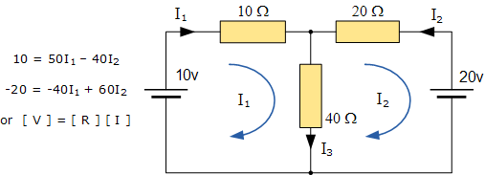

Multiplying 40 to equation (1) and 50 to equation (2)

Then adding both equations we got

-600 = 1400I2

I2 = 0.428A = 428mA

Putting the I2 value in equation (1) we got

I1 = 0.542A = 542mA

**PSPICE Simulator:**

PSPICE is a computer-aided simulation program that enables you to design a circuit and then simulates the design on a computer. As this is one of its main purposes, it is used extensively by electronic design engineers for building a circuit and then testing out how that circuit will simulate.

**Procedure:**

1. Open the schematic program of PSpice
2. Click on the “Get New Part” button on the toolbar
3. Type ‘r’ in the search bar and place the eight resistors on the white sheet
4. Type ‘VDC’ in the search bar and place two of them on the white sheet
5. Type ‘gnd-earth’ and place it on the white sheet
6. Now arrange these components on the white sheet according to the circuit diagram as following

**Diagram:**

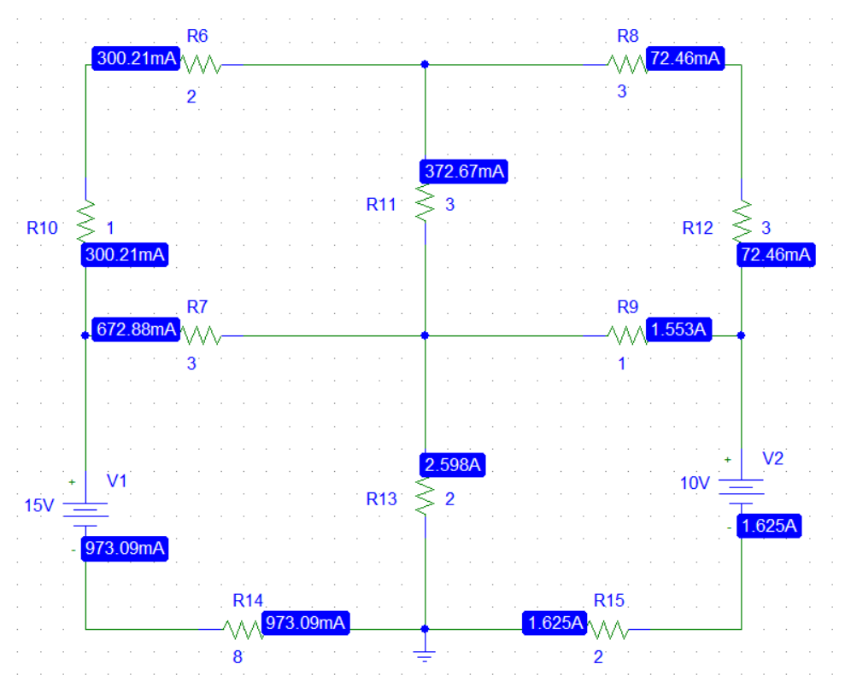

**Observation & Calculation:**

For mesh 1

I1 + 2I1 + 3(I1-I2) + 3(I1+I4) = 0

9I1 – 3I2 – 3I4 = 0

For mesh 2

3I2 + 3I2 + (I2 - I3) + 3(I2 - I1) = 0

-3I1 + 10I2 – I3 = 0

For mesh 3

(I3 - I2) + 10 + 2(I3) + 2(I3-I4) = 0

-I2 + 5I3 - 2I4= -10

For mesh 4

3(I4-I1) + 2(I4-I3) + 8I4 - 15 = 0

-3I1 - 2I3 + 13I4 = 15

Finding I1 I2 I3 and I4

AX=B

X=A-1B

I1 = 0.300A

I2 = -0.072A

I3 = -1.625A

I4 = 0.973A

**PSPICE RESULT:**

|  |  |  |  |
| --- | --- | --- | --- |
| I1 | I2 | I3 | I4 |
| 300mA | 72mA | 1.625mA | 973mA |

**CALCULATED RESULT:**

|  |  |  |  |
| --- | --- | --- | --- |
| I1 | I2 | I3 | I4 |
| 300mA | 72mA | 1.625mA | 973mA |

**CONCLUSION:**

From the experiment, I concluded that Mesh current analysis is the correct way to find the current in the given circuit.

As we verify it by PSPICE and we saw that the calculated result and the PSPICE result are the same.